Matthew Case
Planning Department
Oxfordshire County Council
Council Hall
New Road
Oxford OX1 1ND

Dear Mr Case,

The Oxford Flood and Environment Group objects to the Environment Agency’s Oxford Flood Alleviation Scheme on multiple grounds, both procedural and substantive. These are detailed below. We believe a Flood Alleviation Scheme is needed for Oxford but that the EA has not met its legal and professional obligations for the design of an adequate scheme, the protection of the nationally rare biodiversity within the proposed scheme area, and the large investment of public money for which important elements of the scheme fail to provide the claimed value.
At the heart of the scheme’s problems is the EA’s insistence on digging out some 450,000 cubic tonnes of soil and gravel from the ancient, irreplaceable, floodplain meadows of West Oxford to construct a broad 5 km long channel that in fact provides only 5.4 - 5.7% of the flood alleviation calculated as achievable in the scheme (and that 5.4-5.7% uncertainly).
The bulk of the scheme’s benefits (c.85%) come from the bunds and earthworks to be created in the area of the scheme and the retention of existing techniques of flood management. As set out below there are economic, hydrological, environmental and management problems that place OFAS in violation of NPPF policies. A more flexible and nimbler scheme, able to incorporate twenty-first century whole-catchment and regenerative farming methods for flood alleviation, would make for a more effective and less destructive scheme and one better fitted to an era of extreme climate crisis.
The EA acknowledge that there needs to be a whole catchment solution and that the efficacy of OFAS will decrease over time. So, it makes no sense to put the cart before the horse with the expensive, inappropriate, and damaging channel that will alter an iconic landscape forever and not even succeed in its objectives.
We would suggest implementing the bulk of the scheme that is uncontroversial, rethinking the costly and destructive channel and maintaining and monitoring the effects, while working towards a whole catchment solution.

Below, in Section A, we set out the reasons why the application should be called in by the Secretary of State, Michael Gove, and in Section B how the EA has failed to make its case for the channel as part of the OFAS, and how it violates National planning policies. A separate document sets out the problems the design poses for Green Belt policy.

Oxford Flood and Environment Group was set up in 2021 as a forum to seek independent evidence and expertise on the OFAS and is an unaffiliated grassroots network. A hundred people came to our public meeting in November 2021 and many more attended online. Both the EA and their partner OFA declined to take part. Our website has been accessed thousands of times and serves as a resource for those seeking independent advice.
The petition to save Hinksey Meadows launched just three weeks ago has over 1,000 signatures. https://www.change.org/SaveHinkseyMeadow
We attach a separate document with comments from members of the public.

We are all at personal risk of flooding and have experienced flooding in the past. We desperately need a flood scheme but one that maximises our protection and doesn’t harm the environment or cause harm to other communities. Having analysed all the evidence, supporting documentation and considered multiple viewpoints, it is our conclusion that the present application fails to make the case for the destructive channel, which will have at best marginal short-term gains that could be achieved by more environmentally friendly means.

SECTION A - Appropriateness of decision-making for the application.

The national implications of the scheme make it more appropriately considered at a higher level than the County Council for the following reasons:

A1. OFAS’s channel damages nationally rare biodiversity by removing and endangering 6% of the remaining MG4A grassland in Hinksey Meadow in one of the largest surviving areas of such grassland. Meadows expert Catriona Bass (
http://www.longmeadwildlifesite.org.uk/thames-valley-wildflower-meadow-restoration-project.html ) writes:
"Floodplain meadows are among our rarest habitats in the UK and the most botanically diverse. Hinksey Meadow is over 1000 years old. If it were an animal or a building, bus-loads of tourists would be coming to see the 'last of its kind in the wild'. Recent research by the Floodplain Meadows Partnership at the Open University shows only a 25% success rate of floodplain meadow creation in the UK. Research from the Centre for Hydrology and Ecology predicts that it will take 150 years for the majority of species to colonise a new meadow. So, the chances of replacing this unique habitat -as important part of our cultural heritage as the Ashmolean and Radcliffe Camera - are very slim. There is no scientific evidence for the success of translocation of Floodplain Meadows. Floodplain meadows are one of the few habitats that combine biodiversity with food production."

In a response to the previous EA application Hinksey Meadows was judged to be of higher ecological value than nearby SSSI meadows in the Oxford Preservation Trust’s response. If Hinksey Meadow was designated an SSSI as it ought to be, then the EA would not consider ruining it for a channel and would carry out more robust measures to protect it as they have done with Oxford and Iffley Meadows, which are arguably of lower ecological value.

“The important biodiversity of Hinksey Meadow had not been taken fully into account. In the opinion of the Floodplain Meadows Partnership, the country’s experts in floodplain meadows, the quality of the Hinksey Meadow is better than the Sites of Special Scientific Interest (SSSI) that make up Oxford Meadows Special Area of Conservation (Pixey and Yarnton Meads) and the New Marston SSSI fields on the River Cherwell. Hinksey Meadow and one of the Trust’s fields on the other side of Willow Walk are designated Local Wildlife Sites.
The Trust’s first preference is that the scheme should be remodelled to allow Hinksey Meadow to remain untouched. This important meadow has been managed in the same way for hundreds of years and is classified as MG4a grassland (the Dactylis (Cocksfoot) subcommunity) under the National Vegetation Classification. With 25.6 species per square metre on average, this is the richest, most revered subcommunity of MG4. Such meadows have become increasingly rare and there are just 192 hectares remaining nationally.”
Hinksey Meadows has over 26 species per square metre and is even more precious

The internationally rare Creeping Marshwort, and the only ever successful transplantation of this red-listed plant is also at risk in the scheme. The plant was originally successfully translocated in 1997 as it was struggling in Oxford Meadows

A 2. In its destruction of 133 hectares (328.65 acres) of a classic riverine Oxfordshire landscape, the scheme also contradicts aspects of the policy framework for the Green Belt and has legal implications for the treatment of Green Belt landscapes nationally (see further Appendix Green Belt legal briefing).
The National Planning Policy Framework requires that development respects the importance of biodiversity. It should do this by the following mitigation hierarchy:

· First, and ideally, avoid environmental impacts
· Secondly, mitigate impacts where these cannot be avoided
· Lastly, compensate for damage where mitigation is not possible.
However, where damage is caused to biodiversity, then the Environment Act 2021 requires that compensation must exceed damage by at least 10%.

In failing to observe the mitigation hierarchy, OFAS will cause considerable environmental damage: almost all of this due to the proposed two-stage 5km long flood channel. It needs to be adjudicated at national level.

A 3. Counter to the EA’s declaration that ‘there will be no transport impact from the proposals during operation’, it is manifestly clear that the EA’s suggestion of a 40mph speed limit on the A34 ring road linking with motorways outside Oxford does affect an aspect of the national transport system. The EA’s numerous HGV movements (estimated at 114 per day for at least 15 months over three years) trucking spoil onto the national road system will subject an already notoriously congested area to delays, intensified congestion, and increased pollution.

A 4. Oxfordshire County Council are part of the consortium backing the scheme. While legislation makes it possible for councils to adjudicate on their own proposals, this is not a fair or transparent approach for a controversial scheme of such enormous magnitude. The Human Rights Act of 1998 establishes our rights to have planning applications fairly considered by planning authorities and failure to do so contravenes our rights on a point of principle, which could open the door to legal action in the future. Local planning officers therefore lack the necessary critical distance and are thus placed in an unfair position if they are to be the arbiters of whether the benefits and costs of the scheme meet both national requirements and local needs.

A 5. The OFAS risks contravention of the new legislation of the Environment Act 2021 that obligates all government departments to act to protect and enhance the environment in a climate emergency. The five principles comprise the integration principle, prevention principle, precautionary principle, rectification at source principle, and the polluter pays principle.
The OFAS arguably violates the precautionary principle as it ought to see how various changes work before implementing the whole scheme, particularly the damaging channel. There is also potential violation of the prevention principle, as the known harm of the channel to tree loss, ecosystem loss, protected species and alteration of the river could be prevented by not building the channel.

SECTION B - Substantive objections to the scheme itself.

B 1. NPPF 6: Building a strong, competitive economy

Using the EA’s own data, the channel is a waste of public money costing £23 million for minimal protection. In economic terms not having a channel, or a shorter one that doesn’t impact Hinksey Meadows, makes more sense than the current proposal. EA data assumes that the proposed scheme costs ‘only’ £123M (previous assessments have put it at £154 million, the difference having been taken on by National Rail to construct the culverts at Kennington Bridge). But there has been little adjustment for increased construction costs which have increased markedly in the last three years.
According to independent hydrologists, planners and economic analysts, the channel does not bring certainty and reliability: it will carry only about 15% of the flood flow and river levels are projected to rise by 30%.

The EA’s own review (ES App Q Modelling Review of No Channel) shows that
the channel offers protection to an additional 157 houses and 151 businesses only. As is implicitly admitted in the analysis, careful design of the bunds and earthworks in the scheme (these provide the major proportion of the benefits) can offer protection by less destructive means than the channel.

We quote from an independent analysis of Appendix Q (available on our website: (https://www.oxfordfloodandenvironmentgroup.com/blank-page-12 )
that addresses the EA’s models and costs two alternatives to the scheme:
- Scenario A1. Proposed channel etc. only from Willow Walk south (not through Hinksey Meadow) but other elements kept
- Scenario A2. No channel as far as Old Abingdon Rd, but other elements kept
The appendix provides information about the cost and flood protection of both of these alternatives.
BCR = Benefit-cost ratio; iBCR = incremental benefit-cost ratio, NPV = net present value
The ‘incremental value’ (iBCR) of a scheme must be above 1 to be worth building. In economic terms, not having a channel (iBCR) makes much more sense than having one, and having no channel through Hinksey Meadow makes as much sense as the proposed scheme:

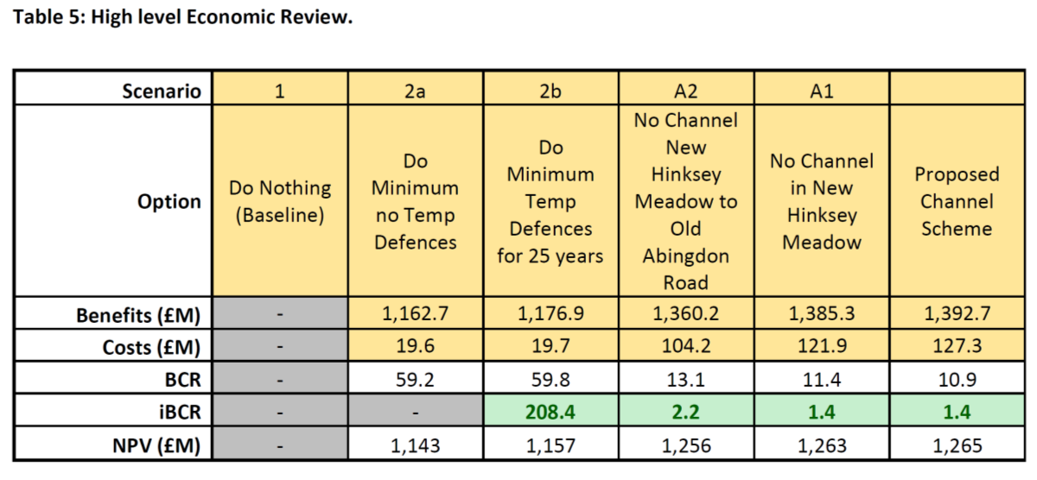
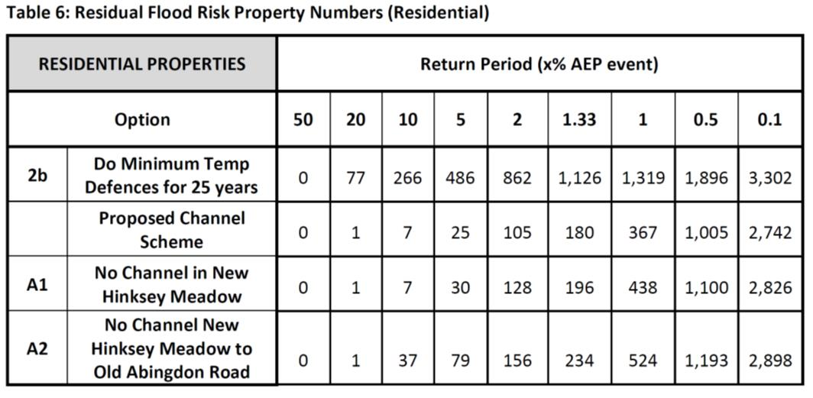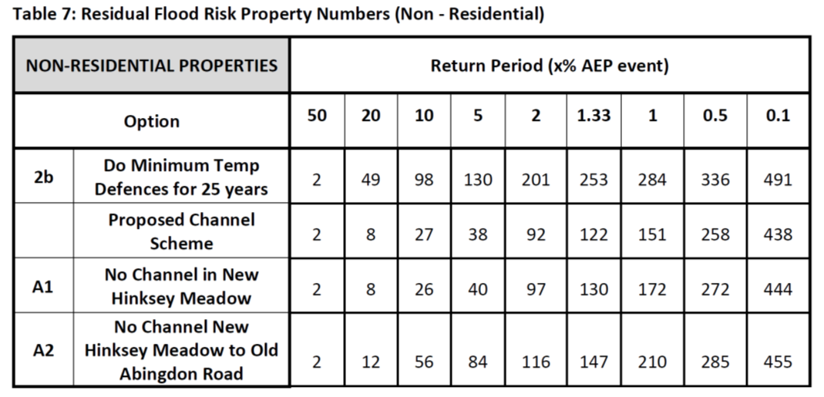
In terms of flood protection, during a 1-in-100-year (1% AEP) flood:
- the full proposed scheme would protect 952 homes (1085 properties) more than ‘do minimum’;
- the scheme without a channel in Hinksey Meadow, protecting the rare MG4 grassland and reducing the scheme cost by £5.4 million, would protect 881 homes (993 properties) more than ‘do minimum’; and
- avoiding most of the channel, with all attendant transport, biodiversity and recreational impacts and reducing the scheme cost by £23 million, would protect 795 homes (869 properties) more than ‘do minimum’.

These tables show the numbers of properties (table 6 for domestic, and table 7 for non-domestic) that have a given annual percentage risk of flooding under the various scenarios (e.g. no scheme, the proposed scheme, scheme without the flood channel).
The 5.4% is obtained by analysis of the information presented within Table 6 of Appendix Q. This shows the number of residential properties at risk of flood. The assumption used here is that the figures in the columns are cumulative.
On this basis there are 1126 residential properties with a 1.33% (or greater) annual risk of flooding for the option “Do minimum: temporary defences for 25 years”.
Under the EA’s scheme this would fall to 180, therefore the scheme improves protection (to a less than 1.33% annual risk of flooding) for 946 residential properties (1126-180).
Under the option “ No Channel New Hinksey Meadow to Old Abingdon Road”, the number of properties with a 1.33% or greater annual risk of flood is 234.
Hence the channel only accounts for 54 of the 946 residential properties. Expressed as a percentage this is 5.7% (i.e. 54/946).
For residential and non-residential properties combined, then the channel accounts for 81 (7.5% ) of the 1077 properties which have their risk reduced to 1.33% or less.

However, one of the EA’s key objectives is to reduce (on the opening of the scheme) the annual risk of flooding to 1% or less for over a thousand properties.
Using their 1% measure, the channel accounts for 157 (i.e. 16.5%) of 952 residential properties with a 1% or less annual risk of flooding.
For all properties the channel accounts for 216 (19.9%) of the 1085 properties with a 1% or less annual risk of flooding.

There is a big difference on numbers depending on the level of flood risk accepted. There will be some improvement to risk under the scheme, but the removal of all risk is an unrealistic goal (especially with the continuing practice of building on floodplains, against the urging of hydrologists and other scientists). And each increment of risk reduction incurs progressively higher financial, environmental and social costs.

Given the channel’s overall cost of £23 million and its limited risk alleviation in comparison with the rest of the scheme, the channel’s costs are excessive considering more environmentally friendly and probably cheaper methods could be used for the same result. We conclude that the contribution of OFAS to building a strong and competitive economy is not proven as value for money, using its own data.

B2. NPPF 2: Achieving sustainable development

As the EA states (ES, 9.1.4, ‘Water Quality’, p. 201), the principal Oxford Sewage Treatment Works are downstream, but there are some local combined Sewer Outfall discharges in the scheme area and there may be foul misconnections into the storm drainage.
The intensive West Oxford development planned around the scheme by the Oxford City Council creates the potential for further sewage and industrial run off.
Wetland landscapes, such as that proposed by the EA, are particularly vulnerable to the problem of maintaining nutrient neutrality (as legally required for wetlands protection) (https://www.theguardian.com/environment/2022/may/02/wetlands-protection-law-delays-new-homes-building-england). The EA is currently without the funding to maintain monitoring sewage pollution even for rivers with a dense surrounding population such as the Thames (5082 sewage outfalls last year from Thames Water, a partner in the scheme). It may apply for a maintenance budget beyond the 10 years after construction as a way of ensuring the scheme’s sustainability, but given it lacks that budget now, the chances of a future budget are unacceptably slim.
Effects on water quality and eco-systems during the scheme’s construction or operation of the scheme are judged as minor to moderate adverse. But the absence of secured maintenance past the initial ten years makes the claim to sustainability dubious, because silting up could minimize the channel’s efficacy further and make the rationale of all the environmental destruction caused by the channel still more insubstantial.

B 3. NPPF 14: Meeting the Challenge of Climate Change, Flooding and Coastal Change

The channel is not effective enough to protect Oxford from these challenges over the claimed 100-year life of the scheme. Independent experts have from the beginning raised serious questions about its function and hydrological performance.
The OFAS fails to build in long term planning even according to its own data. It does not include data for the +30% increase in peak flows in the 2080’s as flooding will be so extensive then. This makes it at best a 60 year not a 100-year scheme.
The problem of the channel’s disproportionate cost and destructiveness and the absence of whole catchment planning is a dereliction from NPPF 14. The scheme only indirectly addresses river surges and flash flooding, which are increasing risks due to climate change. It also only indirectly addresses groundwater flooding, which is a major risk in an area like Oxford that is built on gravel.
Furthermore, there are several apparent discrepancies within the modelling of river flows in App Q, which suggest the data might not be a robust basis for making these decisions. Others evaluating the data have picked up discrepancies and contradictions within the data and in the interpretation of the data. They are more akin to a snapshot and the model is only as good as the data that it fed into it. If this is the basis of decision-making (and dismissing Scenarios A1 with short channel and A2 with no channel to Old Abingdon Rd) then it is not conclusive or robust enough. What the EA has proposed is arguably at odds with the data they themselves have calculated.
For example, water often overflows the embankment south of Godstow lock, which needs to be repaired. It is unclear if the model takes this into account and reflects conditions as if all the water was flowing down the main channel of the Thames. If more water is going to be carried down Osney Ditch, what about the effects of velocity where it joins Osney Stream south of the vicarage in Osney Island, particularly as a significant portion of the bank on one side has been illegally covered in tarpaulin for three years? Might this have unintended consequences? It makes more sense to carry out routine maintenance first and assess conditions on the ground.
These discrepancies between modelling and reality and what is in the data and what the EA claim, undermines the reliability of the data. The fact that we have not had clarification from the EA means we do not have reliable data on which to make a judgement. It should also be noted that the EA often gives the impression of having run hundreds of modelling alternatives. In fact, these are mainly paper exercises.
Email from the EA to OFEG dated 22nd Dec 2021:
“I would clarify that we did not run 100 different models. When the Oxford Flood Risk Management Strategy was completed in 2010, we reviewed over 100 combinations of options, for reducing flood risk in Oxford, but most options were eliminated without the need for a model.”
This shows that there has been little update of the data in 12 years or scenario planning, at a time when climate change and biodiversity collapse have changed the goals and assumptions and there have been developments in flood alleviation that are more environmentally friendly.
The EA and Oxfordshire County Council are in breach of the NPPPF para 153’s requirement that local planning authorities take a proactive approach to climate change, and the County Council has formulated a target of net-zero carbon for 2050. Large scale development creating or releasing carbon must be scrupulously considered.
The ES Non-technical summary for the scheme says: “The whole life carbon dioxide emissions over the project life are estimated at 19,558 tonnes and the operational carbon is 4.65% of this (i.e., 909 tonnes) based on the proposed maintenance regime. To put this into context, a 2019 Oxford City Council report stated that carbon dioxide emissions from the city in 2017-2018 were 718,362 tonnes per year. The emissions due to the Scheme including operation for 100 years would be equivalent to the direct emissions from the city for less than 10 days”.
However, this assessment only measures one element and therefore underestimates the true carbon cost of the project. The loss of the carbon sequestration of ancient flood meadows and mature trees, hedgerows and grasslands is not mentioned let alone measured.
There is ongoing research into the carbon storage capacity of meadows and soil. The Open University’s Floodplain Meadow Alliance researches the carbon-holding properties of flood meadows. In the UK 95% of sequestered carbon is held in the soil: digging up soil always releases carbon into the atmosphere. As the EA has consulted with the FMA it should be aware of this but says nothing of sequestered carbon.
Species-rich flood meadows, where carbon has been held for centuries, hold the most carbon after peat, as the FMA research has shown. Next to peat bogs, there is more carbon stored in flood plain meadow soils than in other ecosystems, to greater depth (down to 2 m in some cases). One of these measures was 313 tonnes of carbon per hectare down to only 50 cm. Tree planting on many of these soils is inappropriate. When one factors in that the EA will dig up 450,000 cubic tonnes of soil from the floodplain meadows for its channel, the likelihood is that there will be massive carbon loss. The EA has not responded to Freedom of Information requests as to how it counts its carbon emissions.
The soil disturbance of (450,000 cubic metres) and the displacement and movement of gravel and soil and other construction emissions, the loss of trees and hedgerows, will have a significant carbon cost, but the EA does not or cannot say what it is. This is not transparent or accountable use of public money and not an adequate response to meeting the challenge of climate change.

The EA also claim under this heading to have met the principles involved by including measures to maintain and enhance biodiversity, landscape, and recreation, three areas that are challenged under separate headings below under their relevant NPPF numbers.

B 4. NPPF15: Conserving and Enhancing the Natural Environment

The most contentious claim and the one with most obvious consequences both nationally and for residents is that the EA is improving the landscape and bringing ‘enhanced bio-diversity’. As mentioned above, destroying an existing ecology and wildlife corridor and replacing it with an inferior one that will take many decades to reach viability is not “enhancing” the natural environment.
Failures to comply with NPPF 15:
- access to the scheme’s area will be compromised for 3-5 years,
- most of Seacourt Nature Park will be permanently lost, as will Kennington Copse.
- There is overall loss of some 4 to 5 kilometres of hedgerows, thousands of trees, and the loss of trees’ capacity for water retention and anchoring riverbanks during floods.
- Loss of MG4a grassland. The current OFAS channel design will have an adverse effect on rare MG4a grassland site in Hinksey Meadows within the scheme and also on other Sites of Special Scientific Interest (Oxford and Iffley Meadows) because these are extremely rare, fragmented and under threat. Given the rarity of MG4a grassland, any threat to the regenerative seedbank threatens this fragile habitat.
- Loss of 1.3 ha of the nationally rare MG4a grassland is calculated separately. EA admits this grassland has a high chance of not successfully relocating: MG4 Grassland Mitigation Strategy, pp. 6, 8.). In fact, the most authoritative research papers show it has never been and is unlikely to be translocatable as it takes so many hundreds of years to develop its systems and high levels of biodiversity. It should also be noted that it is unclear if the EA will aim to replace MG4a grassland as they specify only MG4 in the field they claim for mitigation. MG4 is not the same as MG4a, and while valuable is not as species rich (usually c.15 species compared to c. 25-26).
- Loss of the willows on the east side of Seacourt Stream, facing North Hinksey Lane.
- Loss of about one-third of the willows on Willow Walk, not replaced (Landscape and Habitat Management Plan Sheet 1 of 7). Mature Crack willows can host up to 450 different species of insects, birds, small mammals etc.

In order to comply with paragraph 180 of the NPPF, planning permission should be refused because there is significant harm to biodiversity resulting from this development that cannot be avoided through locating on an alternative site with less harmful impacts. Nor can it be adequately mitigated, or, as a last resort, compensated for (see paragraph 180 of the NPPF).
Under the Environment Act 2021 the scheme must provide at least 10% biodiversity net gain. But it only provides the net gain if:
• Approx. 9.2ha of wet woodland is created off-site
• 4-5km of hedges are planted off-site
• Approx. 730m of ditches are provided off-site (Environmental Statement App. S Biodiversity Metric, pp. 5-7).
However, this assumes the EA’s minimum classification of the existing biodiversity is correct and that the EA do everything they say they will (no accountability if they don’t); and also that everything they do works as planned.
- In terms of planting this is highly unlikely, as a typical attrition rate for new planting can be 40%. Added to that are the muntjac and roe deer that both live on and access the flood plain which will kill any newly planted trees and shrubs. There is no mention of this and no plan to cull them or to deer-fence the project.
- The EA is insufficiently clear about the time taken to equal existing biodiversity. Saplings planted offsite cannot develop to maturity within the projected time of the scheme’s maintenance budget (10-15 years only secured). Each lost tree is an eco-system in its own right and the mycorrhizal fungi network between trees will be decimated. Planting young trees cannot replace mature trees for decades. Crack willows need 45 years. Newly planted hedgerows and tree groups take years to develop into fully fledged ecosystems and to replace the vital mycelium networks that link trees growing in groups.
- Replacing an ancient floodplain with a new wetland (a much easier habitat to create) is not a net gain. We have lost 95% of meadows since WW2. Maintaining wetland also poses large challenges. If not properly maintained it will silt up, diminishing the channel's efficacy even more. There is also very little in the Environment Report about how the ecology of the new channel will be established nor is there any realistic estimate of how long this will take.
- Maintenance problems: The proposed replacement of ancient floodland by wetland does not allow for the fact that if maintenance does not extend beyond 10 years, the wetland and the ‘new ‘natural’ channel’ could clog up and not only impede mitigation but diminish flood protection. There is compelling scientific evidence that disturbed earth is more likely to be colonised by invasive species such as Himalayan Balsam, already a problem in the area.
- Mitigation is claimed through the provision of land that is already open to the public, e.g land behind the Botley Rd shopping malls and the grassland proposed SE of Osney Mead, which has long been managed as good quality semi-improved grassland but would be dug up or scarified and seeded with green hay from Hinksey Meadow. So, this would represent a net loss. There is scientific evidence that only 25% of attempts to establish meadow grassland succeed. Therefore, this mitigation strategy does not meet the criteria in the policy framework.
- Wildlife: EA claims to be creating a new corridor for wildlife through the scheme, but is in fact disrupting an existing one. Its plans assess badger impact at Kennington but not at Seacourt and Jewson’s Field. Otters are dismissed as ‘a mobile species’ that can move themselves out of the way during the scheme. ‘Best safeguards’ are promised for minimising adverse effects on fish.
- Similarly with kingfisher, another protected species, who build their nests by burrowing into the bank. The changes to riverbanks, disturbance during construction and alteration of the riverbeds will inevitably impact on the fragile population. The bat population will also be affected.
- The EA devotes space in their analysis in showing how they are protecting the SSSI locations of Oxford Meadows and Iffley Meadows. Yet it fails to understand the importance of the wildlife corridor and sustaining the whole ecology of our ecosystems. Destroying the West Oxford ecosystem will inevitably compromise nearby ecosystems. Kingfisher, bats, badgers, fish, all move between the various locations, unaware of human demarcations. This vital wildlife corridors will be damaged and lost forever.

B 5. NPPF 8. Promoting health and safe communities
While it claims to create access to high quality open spaces the OFAS actually restricts community access to the principal green spaces of West Oxford for 3-5+ years plus and reduces their extent thenceforth, giving less access to walking and cycling.
8 hectares in existing public space is lost, including much of Seacourt Nature Reserve.
The EA relies on contractors to control pollution and hazards during construction. It adds to the traffic congestion on local roads which already suffer from excess vehicles and pollution.
Much of the proposed scheme is essentially concerned with extracting soil and gravel. Like any such an extraction project, it will harm the health of people living nearby through noise, dust, vibrations and air pollution. Linked with this are mental and physical health issues. Green infrastructure is linked to physical and mental health benefits. The proposed scheme would significantly reduce local residents’ access to green infrastructure during the 3-5 years of construction, and somewhat reduce access during the operation of the scheme.

B 6. NPPF 9. Promoting sustainable transport

- The EA OFAS Planning Statement claims ‘There will be no transport impact from the proposals during operation’.

- As 111 vehicle movements per day for 15 months spread across the three (+?) years of gravel digging are planned, this is a dubious claim and presumably can only be ‘true’ because of the form of words, which must mean national level transport impact. But up to 114 HGV movements per day from South Hinksey on and off the congested A34 near the Hinksey Hill Interchange is not without impact. As noted above, the EA’s request for a 40mph speed limit on the A34 ring road linking with motorways outside Oxford does affect an aspect of the national transport system.

- The EA’s presentation of transport in the scheme as having little effect relies on an inappropriate comparison with existing impacts, whereby its additional HGVs represent 0.17% of the 24 hours Average Daily Traffic on the A34. The A34 is already severely congested: the addition of so many HGV journeys is problematic.

- The EA’s 2018 application invoked consideration of a railway access road to use the Hinksey Sidings for spoil removal: in the 2022 application this is not firmed up but said to be under consideration for a separate planning application. Its likelihood and timeliness in mitigating traffic problems cannot be relied on.

(ii) The EA admits to ‘some impact on the local road network during construction from vehicles travelling to and from the site’ but its claims that this is dealt with because an outline Construction Traffic Management Plan has been submitted are unjustified. The scheme’s traffic will have a major impact for local residents and anyone travelling through Oxford's road network on already congested roads in residential areas where at least three of the WHO air safety criteria are regularly breached to 75% and on the Botley Rd 90% + above permitted levels.

- The main work yard of the scheme is situated right up against South Hinksey village, necessitating noise and disruption (which the EA says it will try to control, but cannot guarantee in the light of the number of vehicle movements and the scale of the digging out of the ancient floodplain meadows and earthwork construction).
- During the construction periods there will be (in addition to movements on and off the A34) up to 35 HGV movements per day from Seacourt Park and Ride onto the congested Botley Road plus contractors’ vehicles from the construction area in the Seacourt Nature Road.
- movement of construction vehicles across the busy Abingdon Road on the proposed haulage routes to the worksite on the southern border of Hinksey Park, ultimately causing further congestion on the A34
- congestion at the south end of the scheme where the main construction access for the Hinksey Stream channel is via the Redbridge Park and Ride

B 7. NPPF 12. Achieving well-designed places

​Despite EA claims that since they are not building a housing estate, they are preserving green belt and open spaces and creating a landscape infrastructure, the key problem is any new designed place is done so at the expense of an existing, thriving ecology. Well-designed places are no substitute for established ecologies maintained with skill and respect. A mitigation habitat of lesser value is no substitute and does not justify the destruction of a rare ecosystem that is irreplaceable.
We would also dispute that the proposed replacement is well-designed. For example,
the proposed ‘motorway style’ paved and railed bridge over the historic Willow Walk introduces an appalling visual on the landscape as well as the loss of 1/3 of the veteran trees. This compares to the current pleasing informal, mature landscape with a pedestrian and cycle path through it.

Before – Willow Walk

After – Motorway Style Bridge (trees after several decades)

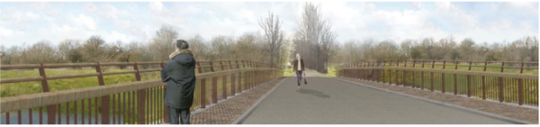

Changing the Devil’s Backbone so that it can carry vehicles also changes the fundamentally rural feel of this location.

The whole conception and design of the scheme fails to reflect local aspirations nor is it grounded in understanding and evaluating each areas defining characteristics. West Oxford greenspace is a historic riverine landscape of ancient flood meadows characterised by mature crack willows. Changing this into wetlands (over 9 hectares of which will be offsite) and cutting down mature willows along Willow Walk and South Hinksey Stream does not observe these guidelines.

The fact that the EA claims this is a scheme for 100 years but budgets maintenance for only 10-15 and has no clear pathway for maintaining the scheme even for 20 years post construction is a further failure to comply with this provision.

B8. NPPF 13. Protecting green belt land

We have prepared a separate appendix to deal with the compliance to Green Belt national policy. This is a summary and general observations.

- One of the five functions of the Green Belt is to preserve the setting and special character of historic towns and this is clearly violated by the scheme. Firstly, it destroys the pastoral setting of West Oxford, celebrated by JMW Turner and Matthew Arnold among others.
- It specifically violates the country village setting of Hinksey village the safekeeping of which was the reason it was acquired by the Oxford Preservation Trust. The alteration to Willow Walk and the risks to Hinksey Meadow are not compliant, particularly as there are alternatives.
- The EA has made a separate ‘Very Special Circumstances’ case in which other considerations outweigh harm. But their argument that it is better that the Green Belt have a flood scheme than a housing scheme in it, especially as whole catchment planning hasn’t been undertaken and will be looked at again (statements vary) in 2028 or 2070 is a dubious compliance with the purpose of the Green Belt.
- The scheme should therefore not be used to justify adjacent development that would contribute to urban sprawl as any additional development would negate the even marginal gains of the other measures. However, the funding of the scheme depends on the Marginal Viability funding for completion, which includes both market and student housing on Osney Mead and cites “beating” a flood risk to facilitate planning permission, as a benefit. There is therefore a risk of “any other harm” contributing to urban sprawl.
- The channel compromises the Green Belt as it causes unnecessarily large environmental damage within the scheme without commensurate benefit.

Furthermore, the risk of environmental catastrophe in a climate emergency arguably violates the precautionary and prevention principles of the Environment Act 2021that all Government Ministers need to consider when making policy. These are not being honoured in this scheme.

The channel also causes a loss of value (unmentioned and uncosted in the EA’s argument for a Special Case greenbelt scheme) in the now recognised welfare costs associated with greenbelt, greenfield and landscape destruction (https://www.thetimes.co.uk/article/green-spaces-have-25bn-welfare-value-with-hyde-park-the-most-valuable-recreation-site-cq0kdbhm7).
The Environmental Statement IMSE500177 (p. 303) refers to the permanent loss of 100 ha agricultural land (around 250 acres). This is an immense amount of green belt land particularly in a traditional pastoral location.
​

B 9. NPPF 17. Facilitating the Use of Sustainable Minerals
The vast amount of excavation and traffic carrying spoil generated by the channel is the chief objection.
While gravels in the area are not designated as a Mineral Strategic Resource Area or Mineral Safeguarding Area in the Oxford Local Minerals and Waste Plan for 2017 according to the EA, site constraints, proximity of residents etc make ‘winning’ the gravels not an option to be easily followed. They conclude gravel is a by-product, not the object of their scheme. The Materials Management Plan (pp. 10-11) estimates 900 c.m per day need to be transported each day in a minimum of 111 vehicle movements, with the longest journey being 280 miles round trip, shorter trips being transporting material from one area of the scheme to another. They are looking at a range of sites (in other schemes and in private companies) north and south and along the A34 and A40 in Oxfordshire and elsewhere to which the spoil can be taken.
There is also a problem with extracting 455,000 cubic tons of alluvial soil and gravel that represent embodied carbon – grassland being second only to peat for carbon sequestration. By destroying a carbon sink, the EA is not using mineral materials sustainably.
B.10. NPPF 4. Decision-making

NPPF 4 specifies that decision-making should include ‘early engagement’ and ‘improved outcomes for the community’, conditions the EA claim to have fulfilled in their Statement of Community Involvement, submitted as part of their application.

The EA have indeed conducted consultations of varying kinds since 2016, and members of the public and various organizations have been expressing concerns on many of the problematic points mentioned in B1-10 above since then. These include the value of dredging and maintaining existing local streams, ensuring maintenance for the proposed channel, use of existing streams/channels as far as possible, and a catchment-wide approach (Consultation response report 2016, pp. 19-20, 22). Preserving the existing habitat and landscape is a priority: ‘Many respondents feel that the best solutions will minimise impacts on wildlife and landscape. Preserving as much of the habitat and landscape features as possible is important to a large majority of respondents’ (p. 23); ‘negative impacts [should be avoided] before considering any approach involving mitigation (p. 36). These concerns carried on through the consultation process as a whole, becoming more granular as more detail became available (for example, 2017 respondents express concern about the proposed design for Willow Walk bridge). Questions about bio-diversity and the consideration of alternatives to the channel persist through to the engagement of May 2021.

There are issues with the quality and nature of the consultations as well as with the EA’s response. As EA itself notes in the report, they discover themselves over the consultation period to be engaging principally with the same, distinctive segment of the population- people not in the throes of bringing up small children, people with established homes and people with time to access and digest information (“66% of people were over 55 and only 1 person under the age of 26 responded to the consultation. 95% of people spoke English as their primary language. We need to consider whether we are reaching all communities in Oxford”, (Report Summer 17, unpaginated report, section 4). Later consultations by the EA have allowed shorter times: during lockdown a web-based consultation of 2 weeks in the EA’s virtual Spring Engagement of May 2021 could have had no realistic aim of engaging with, for instance, women working from home while also home-schooling children. It takes a large amount of time and effort to follow the implications of the scheme and though questions can be asked in various media (Citizen Space’s videos for instance), answers always, unsurprisingly, insist on the rightness of the EA’s positions. The various fora have not included debate or external expert responses, so that the responsibility for understanding the context of the EA’s claims devolves upon residents.

When Oxford Flood and Environment Group held a public meeting with independent speakers in November 2021, audience engagement was not with later EA consultation details (such as choosing a preferred option for bridge handrails), but with the desire for discussion of fundamental issues of the scheme’s design, hydrology, the necessity for the channel and the impact on biodiversity and the green spaces of Oxford. These have remained live matters of concern and unresolved issues in the EA’s 2022 application.

For the application itself there are serious problems with the length of the consultation period. The current application became publicly available on 7th April 2022 and offers a consultation period for public comment till 9th May: four weeks and four days over the Easter and school holidays. The application has an 88-page summary outline and over 300 documents. The Environmental Report alone is over 300 pages. The timing, short period and presentation of immense amounts of data render the process challenging to say the least, particularly for newer residents in Oxford without a history of familiarity with the scheme. While the consultation period may fulfil the statutory or customary requirement for consultation, it is scarcely reasonable for one of the largest and most complex schemes to be put before the public. The time pressure runs the risk of this looking like a consultation in name only.

​There has also been limited communication about the planning application and the deadline. Residents were not sent leaflets informing them that the new application had gone in. A handful of notices were posted throughout the area of the scheme, but the chances of all the residents affected by the scheme walking in the relevant meadows over a four-week four-day period is minimal, especially during the school and Easter holidays when many are away on vacations long delayed by Covid. Given the magnitude of the scheme there is a strong argument that affected residents should have been sent a letter or received a leaflet particularly as the consultation period has run over Easter and bank holidays.

The lack of debate in the consultations (the EA and its spokespeople in OFA controlling the flow of information) has promoted the belief among some residents that they can either have this scheme including the channel or no flood scheme at all. As discussed above (under B.1, B3) this is not the case. Around 85% of the measures can be introduced and aren’t dependent on the channel. The relief of the pinch points at the A43 bridge for example will go ahead and are not tied to the channel. Neither are the bunds and embankments. There is a strong argument for an incremental approach and a “maintain and monitor” strategy.

Conclusion
The Oxford Flood and Environment Group object to the Planning Application submitted by the Environment Agency for all the reasons we have outlined and for violating several core strategies of national planning policy (see especially B1 and B3 above). To sum up: we object to the channel for the following reasons:
- it is not value for money.
- is ineffective as a flood defence and based on questionable modelling and data that is not robust.
- will cause irreparable environmental harm, risks the collapse of the whole Oxford wildlife corridor at a time of climate emergency and biodiversity collapse.
- will cause the loss of the 7 hectares of the irreplaceable 1,000-year-old flood plain Hinksey Meadow and the extracted 1.3 ha will not be translocatable.
- will lead to the loss of 100 ha of agricultural land at a time of food insecurity
- the excavation and disturbance of 450,000 cubic tonnes of soil and gravel and thousands of trees and hedgerows will cause massive loss of carbon sequestration that has not been properly calculated.
- lacks a sustainable maintenance plan beyond 10 years, therefore jeopardising the full running of the scheme
- is not future proof as any solution to Oxford’s flooding problems must be a whole catchment solution.
The EA could have honoured the mitigation hierarchy by properly investigating schemes that either avoided impacts (ie no channel), or mitigated impacts (i.e. a single stage channel), especially as other groups such as HOEG had proposed two such alternatives (smoothed floodplain, and a pumped pipeline) at least four years ago. The EA’s full calculations of net gain do not form part of the planning application. Therefore, the validity of their claims cannot be examined. A FOIA request has been made for these, but has not resulted in their disclosure, despite exceeding the time allowed under the FOIA (20 days).
If this planning application is to be approved with the channel, the EA will irrevocably alter the unique, historic landscape and its ecosystems and sever the connection between river and floodplain that has existed for more than a millennium. It will destroy the habitat of innumerable creatures from voles to skylarks, tear up mature trees and hedgerows with ancient root systems and turn viable agricultural land into a wetland. All this for unproven marginal gains for a channel that is not future proof. The design is not based on wholly robust data nor is it adequately demonstrated that it will in fact effectively reduce flooding risk that could be achieved with more environmentally friendly means. The scale of environmental destruction would be bad enough at any time but in a climate emergency that puts us on the brink of biodiversity collapse risks being branded as ecocide by future generations. There is still time to improve this proposal, and we urge those with the power to do so to avert irreplaceable loss .

Patricia Murphy and Jocelyn Wogan-Browne
Oxford Flood and Environment Group

https://www.euro.who.int/__data/assets/pdf_file/0005/321971/Urban-green-spaces-and-health-review-evidence.pdf; https://www.newscientist.com/article/mg24933270-800-green-spaces-arent-just-for-nature-they-boost-our-mental-health-too/

